
Technology –Software Development and IT

Test Case
LAH Vendor System
(Manual Data Entry)

Version: 0.2

Author: David Modibane
Senior Software Developer

The LAH Vendor System Flowcharts
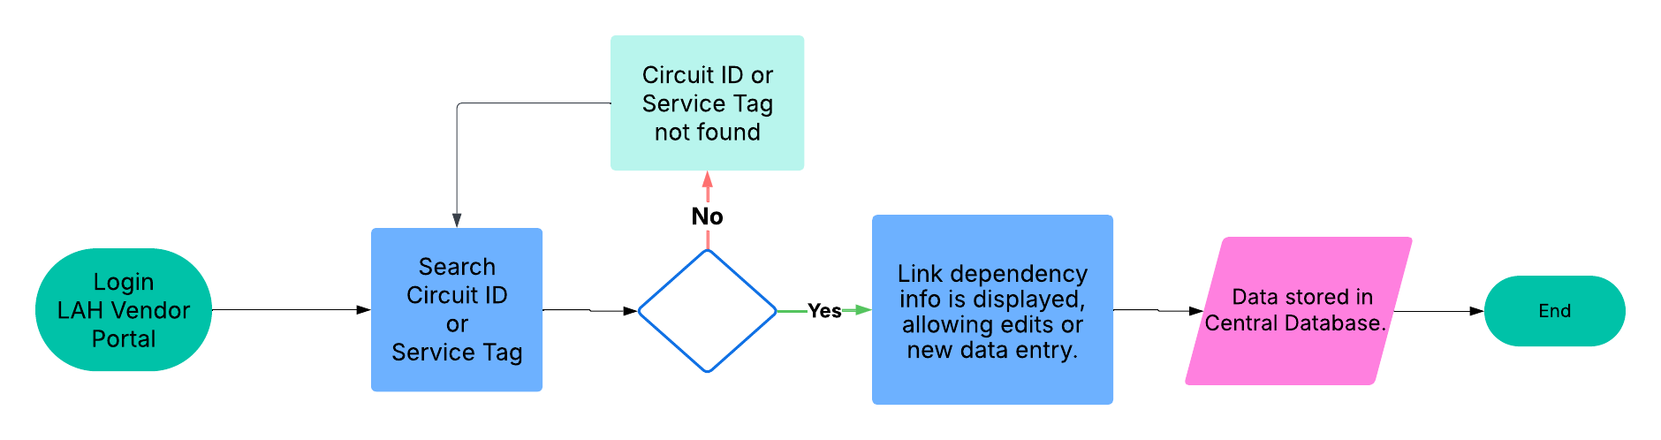

Approvals
Name | Title | Approval | Date
Roith Gareed | IT Manager
Lungile Tshabalala | Business analyst

Test CASES

Test Procedures

ID | Pass | Fail | Test Case Title
TC01 |  |  | LAH- Vendor Entry Capture Process
Success Criteria |  | Vendor Link Dependency data is captured manually in the system.
Workflow |  | Basic Workflow:  1. Login: Access the system.  2. Search: Find items by 'LA Circuit ID' or 'BitCo Service tag'.  3. Select: Choose an item from the dropdown list.  4. ADD (Optional): Enter new data if needed.  5. Submit: Press the 'ADD NEW' button.  6. Delete (Optional): Delete unwanted items.  7. Database Update: Central database is updated automatically.  8. Logout: Exit the system.
Procedure Key finger |  | Step 1: Login to LAH Vendor Service  URL: https://10.250.2.254/lah/index.php  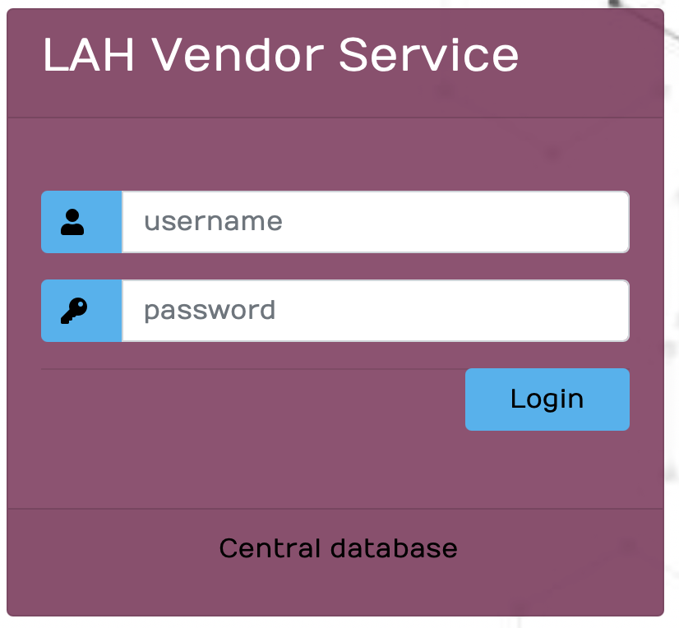  Step 2: To capture vendors information, search for the LA Circuit ID or BitCo Service Tag on the landing page.  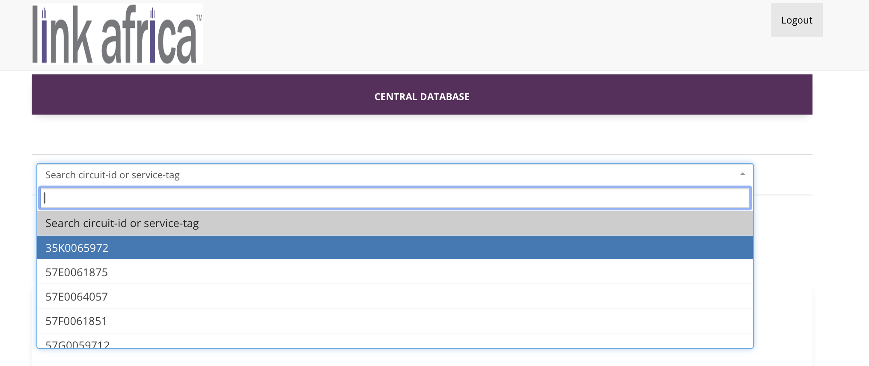  Step 3: After searching, select an item from the dropdown to retrieve circuit vendor information and manage data (view, add, or remove)  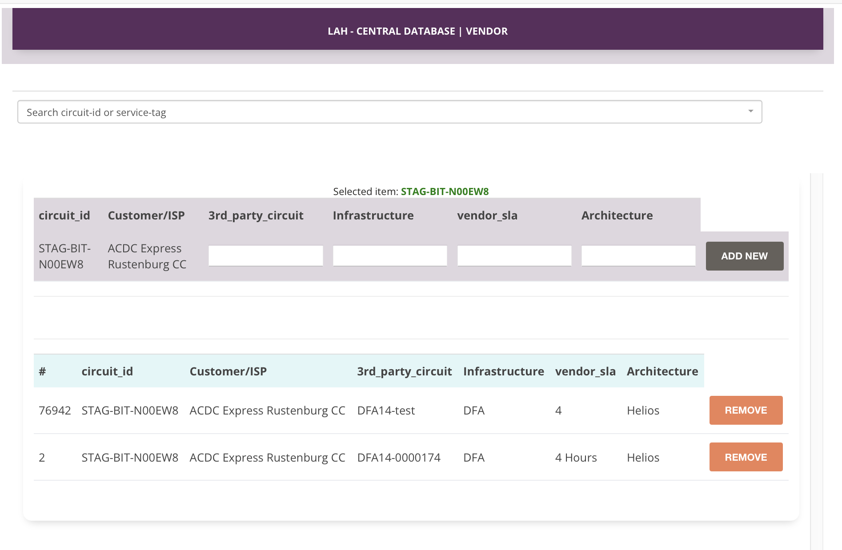  Step 4. Once information is complete, click ADD NEW.  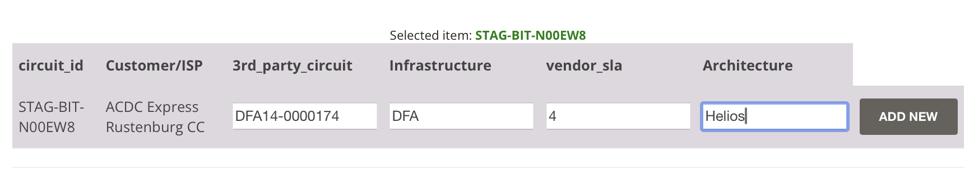  Step 5. Remove items by clicking the REMOVE button.  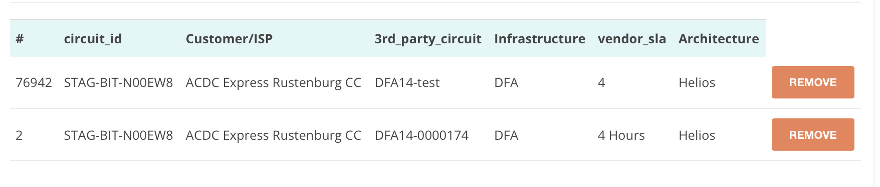  Step 6. Post-save, API payload for STAG-BIT-N00EW8 link dependency.  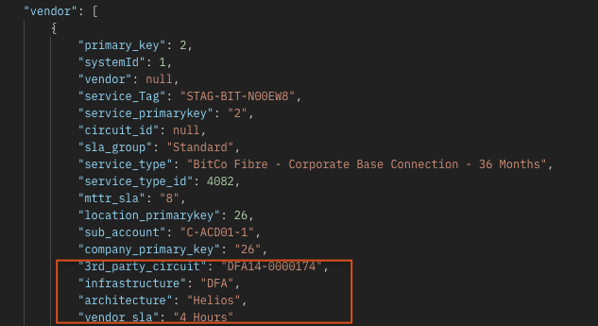
Comments |  | The Central Database tables impacted for this project are:  1. Vendor (stores link dependency data)  2. intranet_users (grants access to the Vendor portal for users)
Conclusion

