
Technology –Software Development and IT

Test Case
LAH Vendor System
(Manual Data Entry)

Version: 0.1

Author: David Modibane
Senior Software Developer

The LAH Vendor System Flowcharts
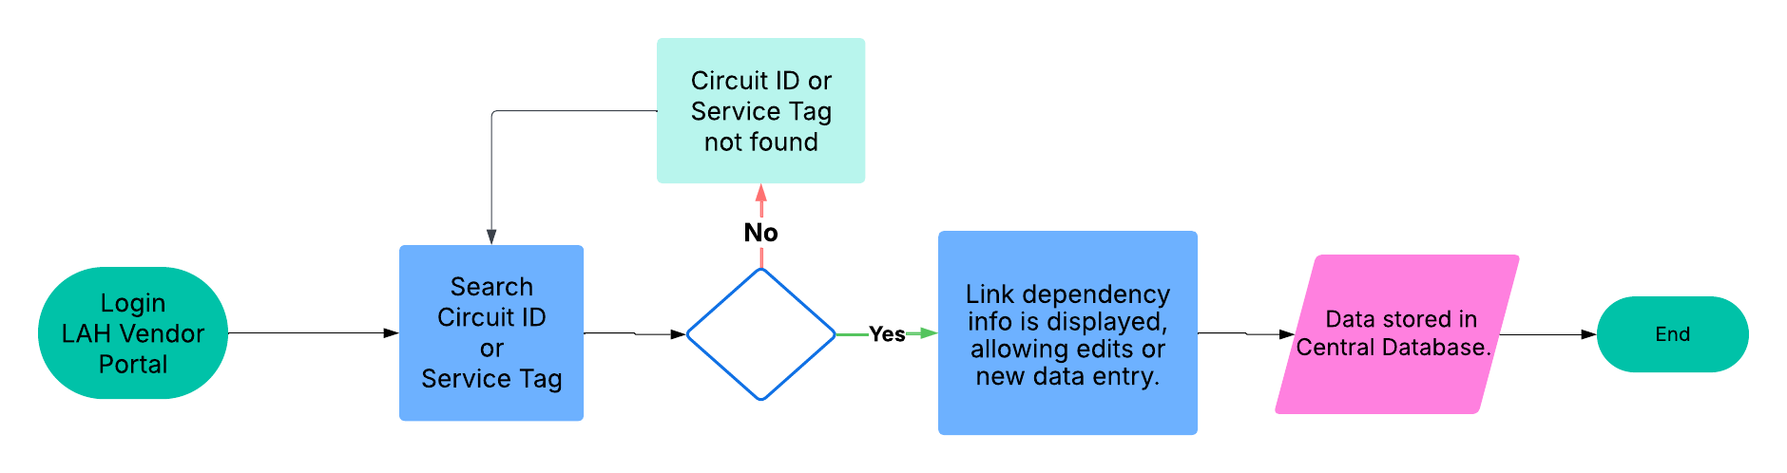

Approvals
Name | Title | Approval | Date
Roith Gareed | IT Manager
Lungile Tshabalala | Business analyst

Test CASES

Test Procedures

ID | Pass | Fail | Test Case Title
TC01 |  |  | LAH- Vendor Entry Capture Process
Success Criteria |  | Manual capture of Vendor Link Dependency data functions correctly.
Workflow |  | Basic workflow:  1. Login.  2. Search ‘LA Circuit ID’ or ‘BitCo Service tag’.  3. Load Data.  4. Edit/Enter New Data (optional).  5. Save Data.  6. Central Database Updated.  7.Logout.
Procedure Key finger |  | Step 1: Login to LAH Vendor Service  URL: https://10.250.2.254/lah/index.php  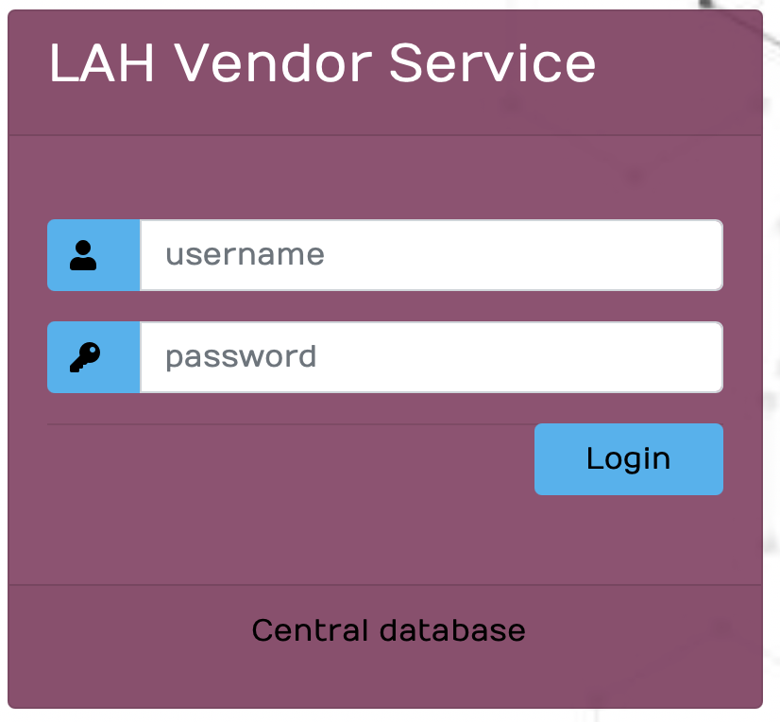  Step 2: To capture vendors information, search for the LA Circuit ID or BitCo Service Tag on the landing page.  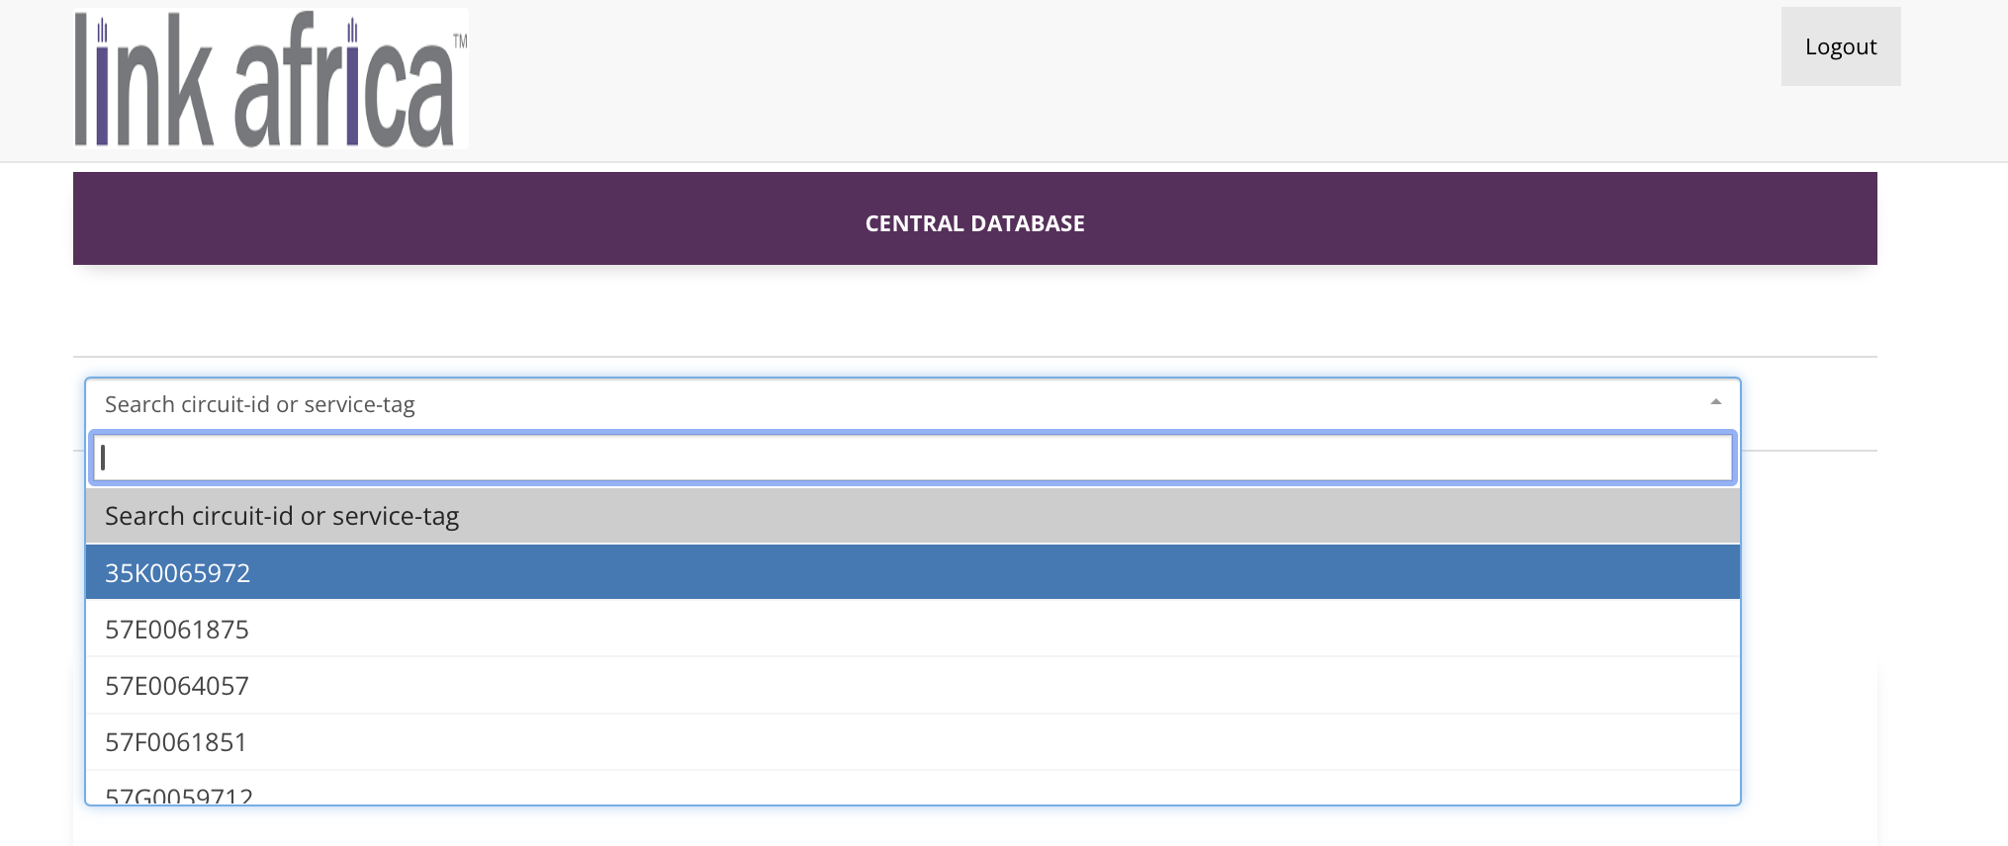  Step 3: After searching, click the 'Load Data' button to generate circuit vendor information.  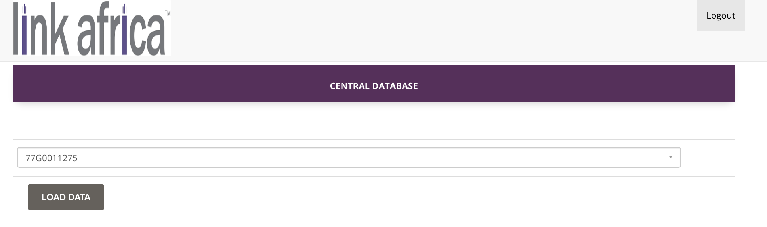  Step 4: Once 'Load Data' is clicked, link dependency info is displayed, allowing edits or new data entry.  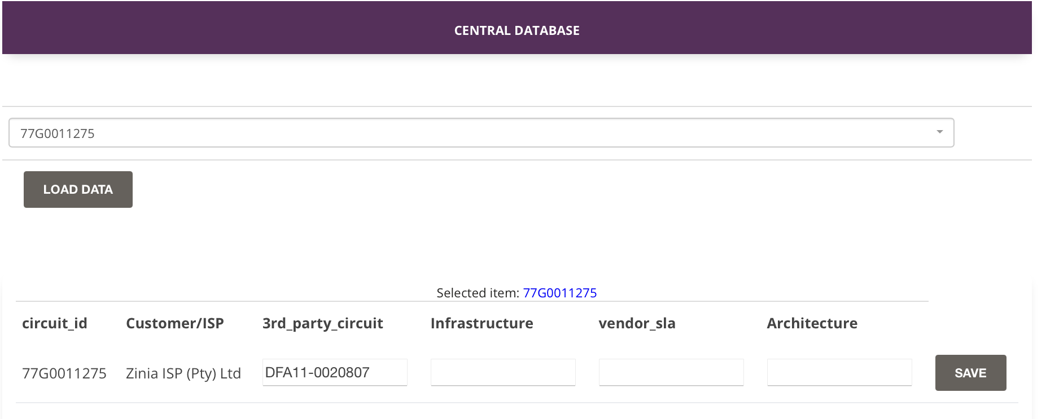  Step 5. Once information is complete, click 'Save'.  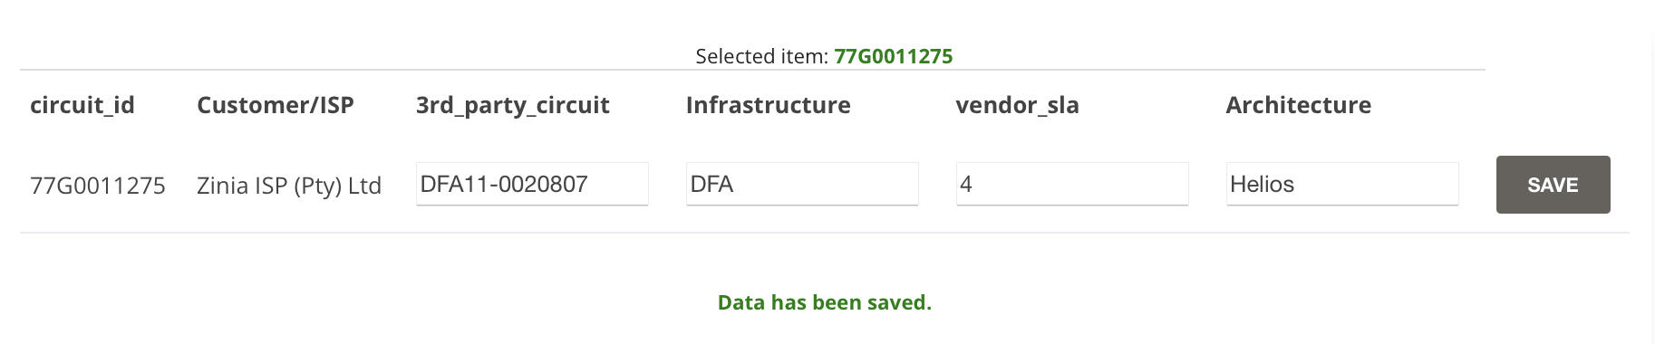  Step 6. Post-save, API payload for 77G0011275 link dependency.  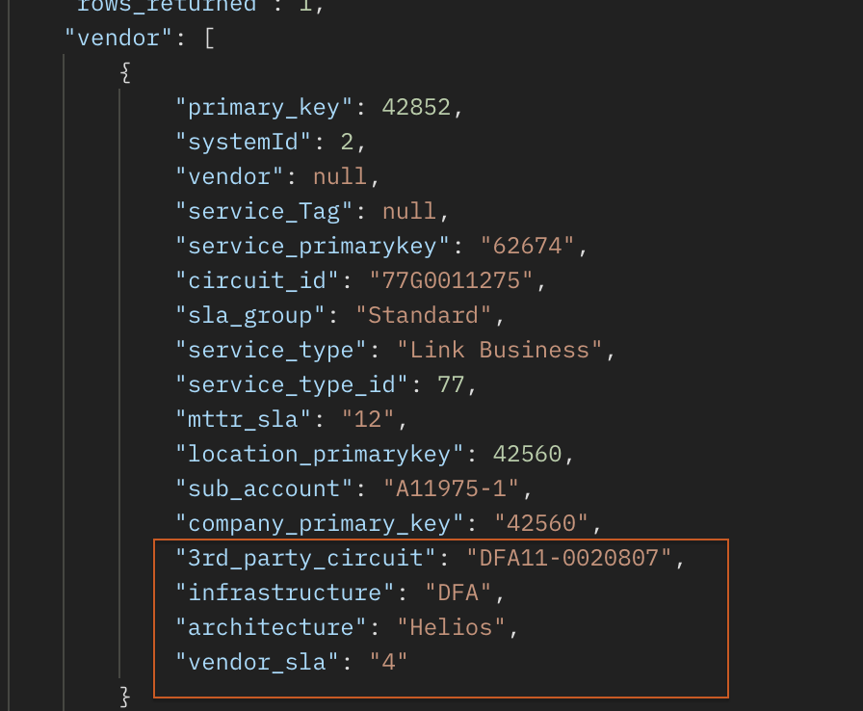
Comments |  | The Central Database tables impacted for this project are:  1. Vendor (stores link dependency data)  2. intranet_users (grants access to the Vendor portal for users)
Request |  | Requirements for the UI on Central DB  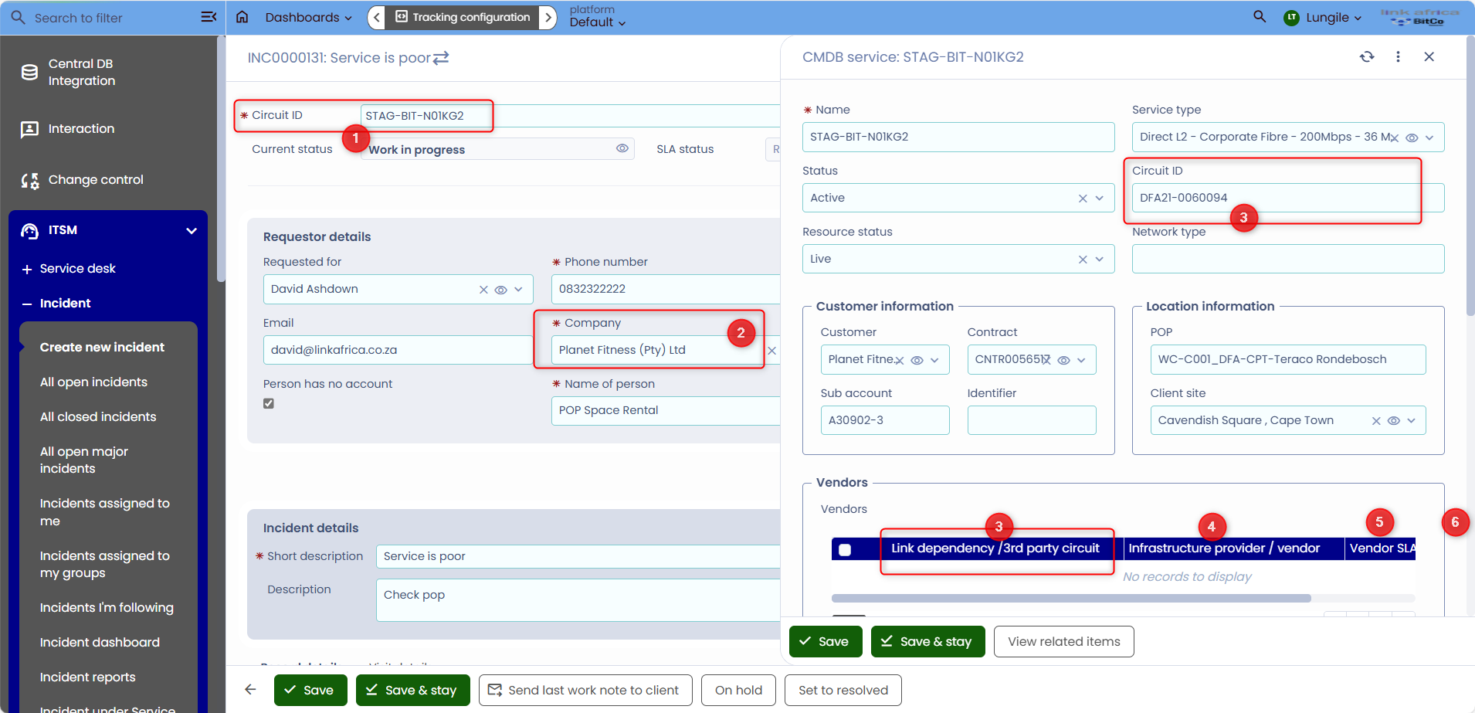
Conclusion

